Communication and Language  We are listening to lots of stories in groups, independently and with our friends. These will become some of our favourites.  In small groups we are talking about ourselves and our family. This will involve talking about what we like to do at nursery and at home and who lives in our home.  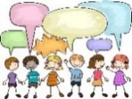  Specific vocabulary related to our topics and events is introduced to the children each week. | Personal, Social and  Emotional Development  We will be helping your child to make friends and build relationships with the children and adults.  We will be supporting your child with the daily routines e.g., arrival at nursery, tidy up time etc… and how to access the activities and resources e.g., wearing an apron when they paint or playing in the sand and water. | Physical Development  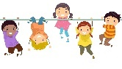  We are developing our gross motor skills such as running, jumping, climbing and balancing through a range of activities including games and playing on the climbing equipment. We play outside every day and get to develop these skills in our outdoor area.  We are developing our fine motor skills through threading, drawing, mark making and painting.  We are beginning to put on our own coats and learning how to fasten them ourselves. | Literacy  We are developing our early literacy skills through, recognising our name on our coat pegs, name cards.  We will be reading labels for children to access different activities and resources throughout the environment.  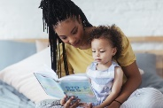  We will be taking part in independent, small group and keyworker group reading time where we will be reading a range of books (fiction & non-fiction).  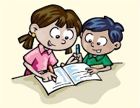  We will be taking part in mark making, there are many opportunities across the environment e.g., writing a message, name writing, writing family names, shopping lists in the home corner.
Alongside our half termly themes we promote learning through the ‘Planning in the moment’ programme by Anna Ephgrave which allows children to lead their play and learning. We plan learning which extends on each child’s ideas. | 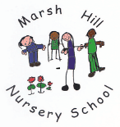  Autumn 1  Me and My Family  & Autumn
Mathematics  Mathematics is everywhere and we do it every day without even realising!!  We will be following daily routines, singing counting songs and rhymes, counting the steps on the stairs, snack time, playing games, recognising numbers and shapes in the environment, and counting how many children are in the keyworker group each day. Most activities we do with your child involve maths. |  |  | Characteristics of Effective Teaching and Learning  This term we are focusing on:  Playing & Exploring  Active Learning  Creating & Thinking Critically  Please see the attached sheet for an explanation of the ‘Characteristics of Effective Learning’. These are also displayed in the area where you drop off your child and pick them up.
 | Expressive Arts and Design  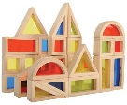  We will be taking part in a range of different activities to develop our expressive arts and design skills. These will involve; building models with the different construction kits, role play in our home corner, music and singing where we will begin to build a repertoire of songs. Also painting and collage activities in our creative area. Your child will bring home their creations. | Understanding the World  We will be learning about ourselves and our families through circle time, reading stories, speaking and listening activities, games and creative activities. We will be discussing that all families are different, but they all love us.  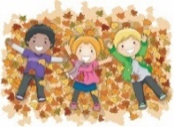  Through our learning about the season of autumn we will be observing the seasonal changes and describing what is happening e.g., the leaves changing colour and falling from the trees, animal hibernation and seed observation. We will also be learning what we need to wear when we’re playing outside and how to keep warm.

